**Social and Emotional Learning Results**

The two charts below demonstrate the reduction in discipline referrals after the implementation of ACE.

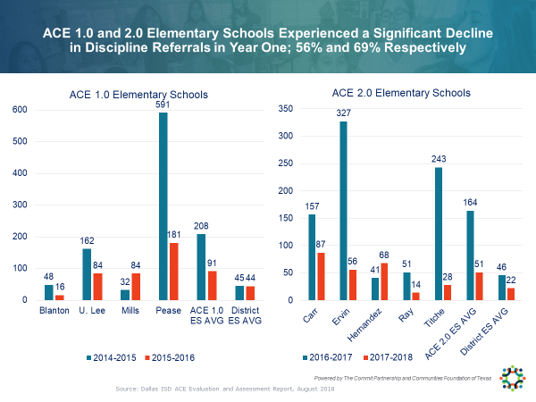

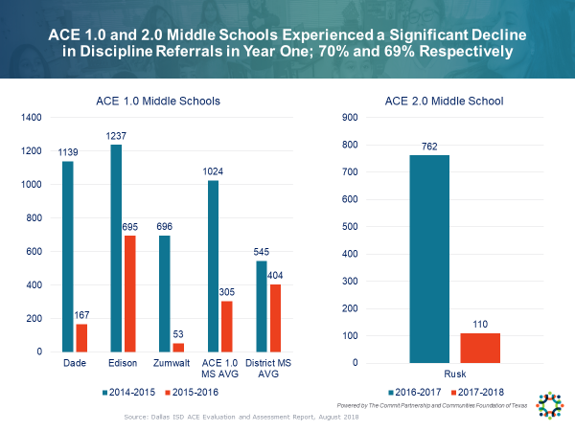

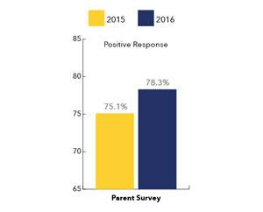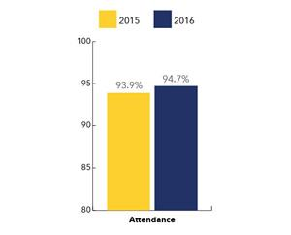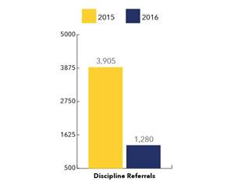The data charts below demonstrate the reduction of discipline referrals, increase in student attendance and increase in positive parent responses after a year of ACE implementation in Dallas ISD.