The following organizations are external providers districts have contacted with to support the instructional implementation of ACE:

Teaching Trust

Teaching Trust develops education leaders at all levels to build the professional capacity critical to transforming urban schools.

Big Rock

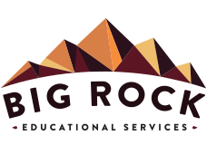
Big Rock Educational Services works directly with school leadership teams to collaboratively identify, prioritize, and implement effective school systems aimed at increasing student achievement.

Education Resource Group

ERG offers professional development designed to empower educators and students. These offerings include job-embedded coaching, workshop sessions, demonstration lessons, focus walks, and individual observation and feedback conversations.

