MidYear assessment Leader Action Plan
Plan Dates: _______________

Rationale:

SECTION 1: DATA AND GOALS

2018-2019 Schoolwide Accountability Goal
Rating: ___

 | Domain 1: | Approaches | Meets | Masters
2019 STAAR Goal

Domain 2A: | % of students meeting STAAR growth target
2019 STAAR Goal

Current Data: 2018 MidYear assessment Scores-
Orange denotes areas where the average is off goal by more than 10 points
Green denotes areas where the average is meeting the goal

MidYear assessment Scores:
**Each number below shows the percentage of students who scored at the approaches, meets, and masters level based on their scale score.
 | Approaches | Meets | Masters
Grade/Content:
Grade/Content:
Grade/Content:
Grade/Content:
Grade/Content:
Average:

**Each number below shows the percentage of students who met their STAAR growth target on the MidYear assessment. (4th & 5th grade STAAR growth target comes from the state, based on their performance from last year and their projected growth for this year. 3rd grade has no growth targets from the state.)
% Meeting Growth Target
Grade/Content:
Grade/Content:
Grade/Content:
Grade/Content:
Overall Average:

Current Accountability scores based on MidYear assessment results:

 | Domain 1: | Approaches | Meets | Masters
2019 STAAR Goal
Current

Domain 2A: | % of students meeting STAAR growth target
2019 STAAR Goal
Current

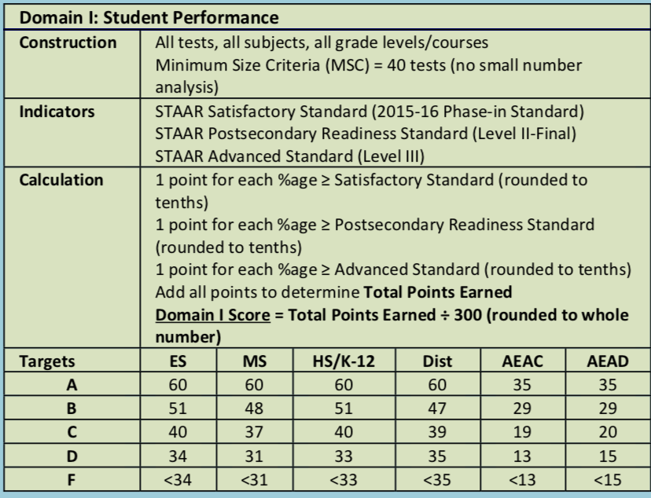

(_____________ (content) MidYear assessment Data by Teacher/Section:
**Each number below shows the percentage of students performing at approaches, meets, and masters for each teacher by section.
Teacher/Section | Approaches | Meets | Masters
Out of Place Students for __________________ (content)
**The below students are performing below their individual growth target given to them by the state for the 2019 STAAR, based on current MidYear assessment data.
Student | Section | STAAR Progress Goal | MidYear Assessment

Student | Section | STAAR Progress Goal | MidYear assessment

Student | Section | STAAR Progress Goal | MidYear assessment

Student | Section | STAAR Progress Goal | MidYear assessment

Student | Section | STAAR Progress Goal | MidYear assessment

Student | Section | STAAR Progress Goal | MidYear assessment

Student | Section | STAAR Progress Goal | MidYear assessment

Student | Section | STAAR Progress Goal | MidYear assessment

Student | Section | STAAR Progress Goal | MidYear assessment

End of Plan Goal for ___________(your content area) by (end date):
**At the next common assessment or benchmark, the following scores would be achieved based on this intervention plan:

 | Domain 1: | Approaches | Meets | Masters
2019 STAAR Goal
Current Reality
End of Plan Goal:

Domain 2A: | % of students meeting STAAR growth target
2019 STAAR Goal
Current Reality
End of Plan Goal:

Midpoint Check: (describe the checkpoint halfway through-when, where, how, etc?)

SECTION 2: ROOT CAUSE ANALYSIS AND ACTION

General overview of Grade/Content Area performance:

Coaching Actions for Teachers:

Teacher: _______________________

 | Approaches | Meets | Masters
School Goal
Teacher Overall Average:
Teacher Section:
Teacher Section:
Teacher Section:
Teacher Section:
Teacher Section:

- Root cause: (what is the underlying issue(s) causing these results?)

Teacher Action | Frequency

Coaching Moves | Frequency

Teacher: _______________________

 | Approaches | Meets | Masters
School Goal
Teacher Overall Average:
Teacher Section:
Teacher Section:
Teacher Section:
Teacher Section:
Teacher Section:

- Root cause: (what is the underlying issue(s) causing these results?)

Teacher Action | Frequency

Coaching Moves | Frequency

Teacher: _______________________

 | Approaches | Meets | Masters
School Goal
Teacher Overall Average:
Teacher Section:
Teacher Section:
Teacher Section:
Teacher Section:
Teacher Section:

- Root cause: (what is the underlying issue(s) causing these results?)

Teacher Action | Frequency

Coaching Moves | Frequency

SECTION 3: PROGRESS MONITORING AND CELEBRATIONS

Monitor & Maintain:

Culture of Celebration:
- Longer term-

- Shorter term-

