Dallas ISD

Implementation Year: 2014-2015
Overview: An annual, overall evaluation rating is comprised of three components in varying weights depending on teacher category:
- Teacher Performance
- Student Achievement
- Student Experience
Evaluation Components:
Evaluation Categories: Teachers are placed in one of four categories:
- Category A: Include most third- through 12th-grade teachers, whose students take ACP and STAAR.
- Category B: Includes most kindergarten through second-grade teachers whose students take TerraNova/Supera and ACP assessments.
- Category C: Include third through 12th-grade teachers whose students do not take ACP or STAAR. The Student Learning Objective and school’s STAAR results determine the achievement points.
- Category D: Includes prekindergarten teachers and teachers not-of-record, such as special education inclusion and Talented and Gifted teachers. Students of Category D teachers do not take ACP or STAAR. Achievement will be measured based on Student Learning Objective and school’s STAAR results. If school’s STAAR results are not available, the 20 percent will be based on the SLO.
A target distribution is used to determine points awarded for individual student achievement metrics, with the exception of Student Learning Objectives (SLOs). A target distribution is also used for Student Experience and at the Category level to determine Evaluation Rating.
- Unsatisfactory: 3%
- Progressing I: 12%
- Progressing II: 25%
- Proficient I: 40%
- Proficient II: 12%
- Proficient III: 6%
- Exemplary: 2%

Student Achievement: Multiple measures of student achievement are included whenever possible. The achievement score makes up 35 percent of the overall evaluation for Category A and B teachers and 20 percent of the evaluation for Category C and D teachers.
- All teachers have two measures of student achievement included:
- Student learning objectives (SLO)
- School STAAR
- For Category A and B teachers, achievement templates include additional measures that are tied to the types of courses taught by the teacher and will include the appropriate standardized assessments for their grade and content.
For School STAAR and for measurements of achievement included for Category A & B, status (% passing or at level) along with two growth calculations (CEI and Academic Peer Group) are included with the teacher receiving the highest of three metrics for each student achievement component.

Student Experience: Student surveys are a component of teachers’ evaluations for those who are a teacher of record for grades 3‐12. Panorama is the current survey administrator.
The Measures of Effective Teaching (MET) Project (www.metproject.org) found student surveys of teacher performance had a higher correlation with a teacher’s success with students than classroom observations. The research found student surveys not only provided an accurate picture of teacher performance that confirmed the results of observations and student assessment results, but also provided a source of helpful feedback that teachers can use to improve their instructional practice.

Compensation: Base salary and salary increases are differentiated by teacher effectiveness level.

For more information, see the Dallas ISD website here.

District of Columbia Public Schools

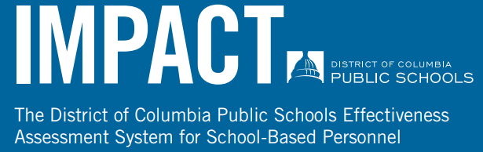

Implementation Year: 2009-201
Overview: An Annual evaluation comprised of the following components. The size and the inclusion of components is dependent on which group the teacher is evaluated under.
- Essential Practices (EP)
- Student Achievement Data
- Student Surveys of Practice (SSP)
- Commitment to the School Community (CSC)
- Core Professionalism (CP)
Evaluation Components:
Evaluation Categories: Teachers are placed in one of 7 groups:
1. Teachers Grades 4+ with Individual Value-Added Student Achievement and Student Survey Data
1a. Teacher LEAP Leaders Grades 4+ with Individual Value-Added Student Achievement and Student Survey Data
2. Teachers Grades 3+ with Student Survey Data
2a. Early Childhood Education Teachers
2b. Small Group Intervention and Grades 1-2 Teachers
2c. Teacher LEAP Leaders Grades 3+ with Student Survey Data
2d. Small Group Intervention and Grades 1-2 Teacher LEAP Leaders
2e. Early Childhood Education Teacher LEAP Leaders
3. Special Education Teachers
3a. Special Education Teachers - Communication and Education Supports CES Program
3b. Special Education Teachers - Early Childhood Education
3c. Special Education Teachers - Communication and Education Supports CES Program - Early Childhood Education
3d. Itinerant Special Education Teachers
3e. Special Education Teacher LEAP Leaders
3f. Special Education Teacher LEAP Leaders - Early Childhood
5. Itinerant English Language Learner ELL Teachers
6. Shared Teachers
7. Home Hospital Instruction Program HIP Teachers

There are five IMPACT ratings and a target distribution is not used.:
- Ineffective
- Minimally Effective
- Developing, Effective
- Highly Effective

Student Achievement: Student Achievement Data is measured two ways: Individual Value-Added Student Achievement Data (IVA) and Teacher-Assessed Student Achievement Data (TAS).
  - IVA is a measure of the impact a teacher has on students’ learning over the course of the school year, as evidenced by the PARCC.
  - TAS is a measure of a teacher’s students’ learning over the course of the year, as evidenced by rigorous assessments other than the PARCC.

Student Experience: Student surveys are research-based tools that capture and value the unique perspectives of DCPS’ most important stakeholders— the students. Tripod is the current survey administrator.
Students in grades 3-12 are eligible to complete survey.
In addition, the survey results provide teachers with specific, actionable feedback to inform their instruction.

Compensation: IMPACTplus is a performance-based compensation system for members of the Washington Teacher’s Union (WTU) and Council of School Officers (CSO) who are evaluated under IMPACT. Any WTU or CSO member who earns an IMPACT rating of Highly Effective is eligible for an annual bonus.
In addition, Highly Effective and Effective teachers who reach the Advanced Teacher LIFT stage and Highly Effective teachers who reach the Distinguished Teacher and Expert Teacher LIFT stages at high-poverty schools may be eligible for base salary increases.

For more information, see the DC Public Schools website here.

Denver Public Schools

Implementation Year: 2013-2014
Overview: An annual evaluation comprised of two components:
- Professional Practice
  - Observations
  - Professionalism
  - Student Perception Surveys
- Student Growth
  - Student Learning Objective
  - School Performance Framework
  - Individual state test results
Evaluation Components:
Evaluation Categories: For teachers without individual state test results or Student Perception Survey data, the distributions will vary. As required by Colorado state statute, student growth consists of both individual and collective measures as well as state assessments and must be 50% of a teacher’s rating.

There are four possible LEAP ratings and a target distribution is not used:
- Not Meeting
- Approaching
- Effective
- Distinguished
Student Achievement: Colorado law requires the following: The Student Growth component of LEAP is 50% of teachers’ overall ratings in accordance with Senate Bill 10-191 and State Board of Education Rules
- Individual Measure: Each educator is required to have at least one measure of student learning that is individually attributed. At DPS these are the SLOs.
- Collective Measure: Each educator is required to have at least one measure that is collective (defined as “more than one educator”). At DPS this is the School’s SPF growth measure.
- State Assessments: Results from statewide assessments must be included, when available and appropriately connected to the subject, grade or course for each educator. At DPS this is individually attributable CMAS growth.
Growth: Results from the Colorado Growth Model must be included for subjects with statewide results in two consecutive years. At DPS this is included in individually attributable CMAS growth and in the School’s SPF growth measure.

Student Experience: Student Perception surveys are a component of teachers’ evaluations for those who are a teacher of record for grades 3‐12. Tripod is the current survey administrator.
The SPS is:
- A measure of each student’s viewpoint of the functionality of their teacher’s classroom.
- A valuable coaching and professional development tool for teachers and school leaders, best utilized when preparing Professional Growth Plans (PGPs), individualized coaching sessions and professional learning opportunities that are aligned to specific areas of strength and growth.
An objective, research-based tool that has been refined based on data analysis and feedback from the field.

Compensation: Teachers who work in a school designated as “highest priority” may be eligible for additional incentives that are tiered based on an individual’s LEAP performance. Additionally, the Professional Evaluation Procomp incentive is based on a satisfactory evaluation with LEAP.

For more information, see the Denver Public Schools website here.

Tennessee Department of Education
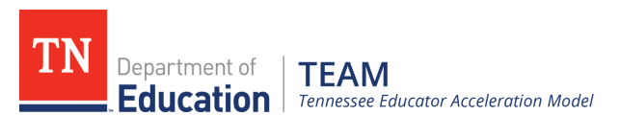

Implementation Year: 2011-2012
Overview: An annual evaluation comprised of the following components.
- Teacher Performance
- Student growth and student achievement.
  - For teachers with individual value-added scores, the student growth measures shall be comprised of TVAAS scores.
  - For teachers, librarians, counselors and other groups of educators who do not have individual TVAAS scores, districts will choose from a list of options that have been shown capable of measuring student growth. The list of options is approved by the Department of Education prior to the start of each school year. The current list of options includes:
    - Early Grades Assessment
    - Student Growth Portfolio Models
      - Fine Arts
      - First Grade
      - Physical Education
      - Pre-K/Kindergarten
      - World Languages

Evaluation Components:
Evaluation Categories (through 2019):
The Tennessee Teaching Evaluation Enhancement Act created a phase-in of TNReady in a teacher’s evaluation score to acknowledge the state’s move to a new assessment, fully aligned to Tennessee state standards, with new types of test questions.
Below are the weightings as identified in the act. Read more details in this FAQ document: 2016-17 Evaluation Options for Educators (May 10, 2017)
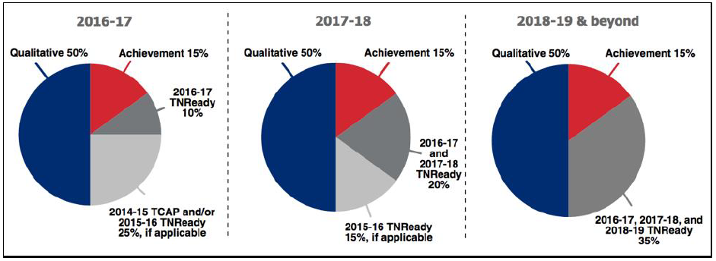

Student Achievement: The quantitative portion of TEAM combines student growth and student achievement. The State Board of Education approved options for teachers and principals for the 15 percent achievement measure component that reflects those measures that showed a relationship to student growth and that could be returned in a timely manner. Teachers should meet with their evaluators early in the school year to choose a 15 percent measure and set clear and rigorous goals.
As with all approved achievement measures, districts have discretion with how they choose to set the scale scores (score range). This practice should encourage districts to use the 15 percent measures to set academic achievement goals and measure progress towards those goals.
For instructions on batch-uploading achievement measures into TNCompass, click here: Growth & Achievement Measure Import Instructions.

Student Experience: Student Experience voice is not included.

Compensation: Base Salary and salary increases are differentiated by Years of Service and Degree Level

For more information, see the TN Department of Education website here.

